|  |  |
| --- | --- |
| **Drafted by:** | **Date:** |
| Howard Tibbs |  |
| **Version:** | **Type:** |
| 1.0 | Website |

|  |  |
| --- | --- |
| **Client:** | Kathy Baker |
| **Email:** | [kbaker@gmail.com](mailto:kbaker@gmail.com) |
| **Company:** | Newman Energy |
| **Company Role:** | Project Manager |
| **Phone:** | 800-444-9999 |

Decision Makers:

|  |  |  |
| --- | --- | --- |
| **Name:** | **Role:** | **Contact Phone:** |
| Kathy Baker | Project Manager | 800-444-9999 |
| Tyler Newman | CEO | 800-344-9999 ext. 126 |
| Cortez Milner | COO | 800-344-9999 ext. 143 |
|  |  |  |

**Project Company Overview:**

Newman Energy will look to make a statement in the energy industry through application of solar and wind energy technologies and solutions. The company will look to become one of the world’s leader providers of Renewable Energy (RE) products and services. This company has developed and created in 2012 by Tyler and Riley Newman.

Newman Energy will provide affordable electricity to the state of New Jersey by offering attractive financing options for Newman Energy’s solar electric systems. This will allow families to make payments in small manageable installments. In addition to this, N.E. will construct a 25,000 watt solar/wind power station and eco-friendly community center.

**What is your target audience? :**

1. The general public – Most of our website traffic will come from the general public to which will visit the site for product, service, and data information.
2. Entrepreneurs – With the launch of our community center, we are looking to create an atmosphere where aspiring entrepreneurs young and old could create new ideas for energy.
3. Partners – We will continue to build our brand and our relationships with companies and industries all over the world.
4. Media – We would like for our company to be featured with the many media outlets to get the word out of our company.

**Do you have any content at the moment? :**

There is no content at the moment, however it will be addressed during the kickoff meeting.

**What is the project’s main purpose/scope:**

The project’s main purpose is to establish web presence and increase marketing and product branding. They will also have a platform for customers with questions and feedback on their services and a portal for signing up for Newman Energy and eCommerce for other products and services.

**Desired Outcome:**

The desired outcome of the website is to establish enough web presence and information in order to sign up for the utility service.

**Navigation Structure:**

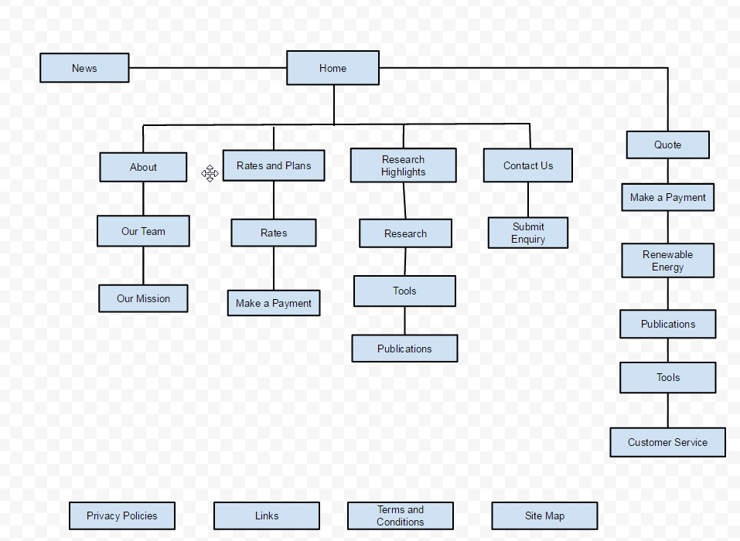

The Newman Energy website will contain the following navigation structure. Suggestions on page structure and organization are welcome:

* Home
* About
  + Our Team
  + Our Mission
* Rates and Plans
  + Rates
  + Make a Payment
* Research
  + Research Highlights
  + Tools
  + Publications
* Contact Us
  + Submit Enquiry
* Quote
* Renewable Energy
* Customer Service

At this time, the website will start with approximately 26 pages for launch.

**What are the features you are looking for? :**

They are looking for a monthly newsletter, a contact form for customers, and an eCommerce shop for merchandise.

**Who are your competitors? :**

Atlantic City Electric

JCP&L

PSE&G

**Do you have a logo, corporate colors, and/or brand book:**

They have not created their own brand book. The company colors are green, white, yellow, black, and blue.

**Search Engine Optimization (SEO):**

Keywords:

-Newman Energy

-Energy

-NJ Energy

**What characteristics describe your brand? :**

Their branding is focused on the family and is family/people oriented.

**What is your inspiration behind your project? :**

The inspiration websites are below:

Energy.gov

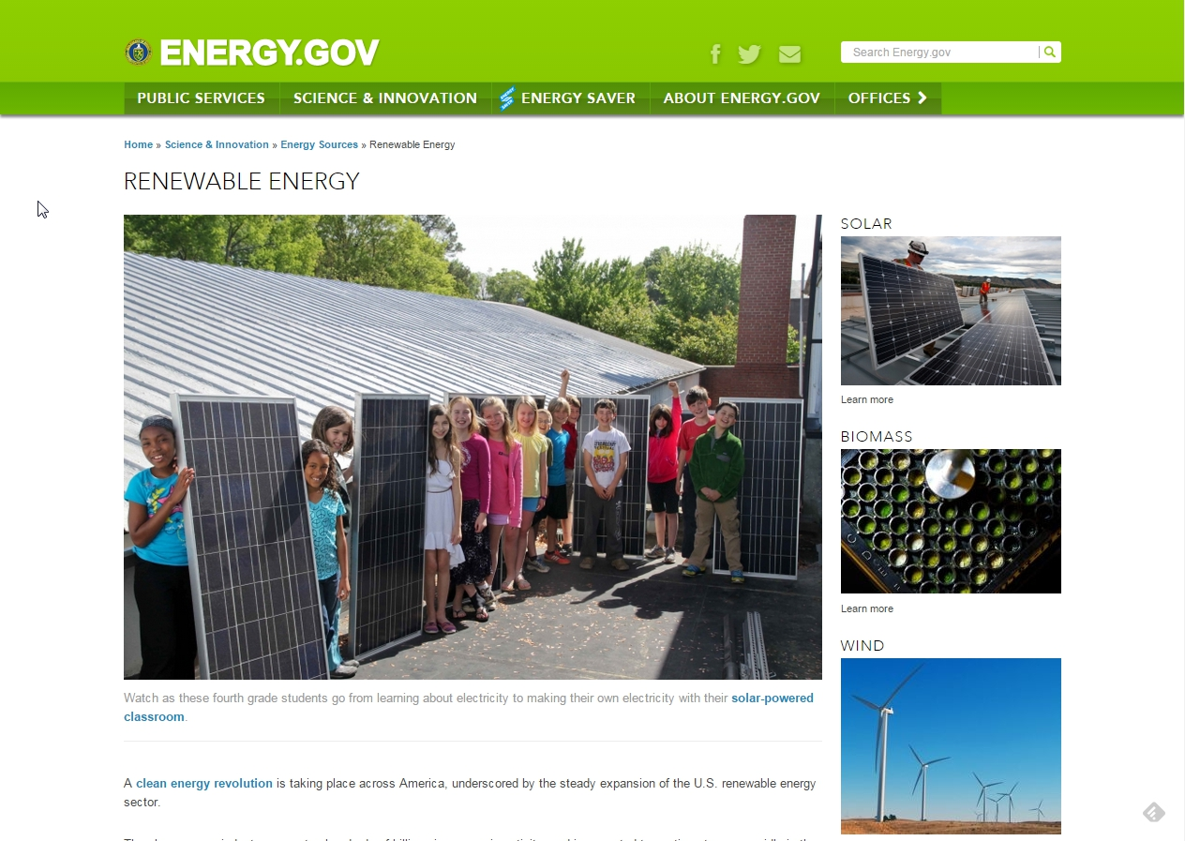

Pseg.com

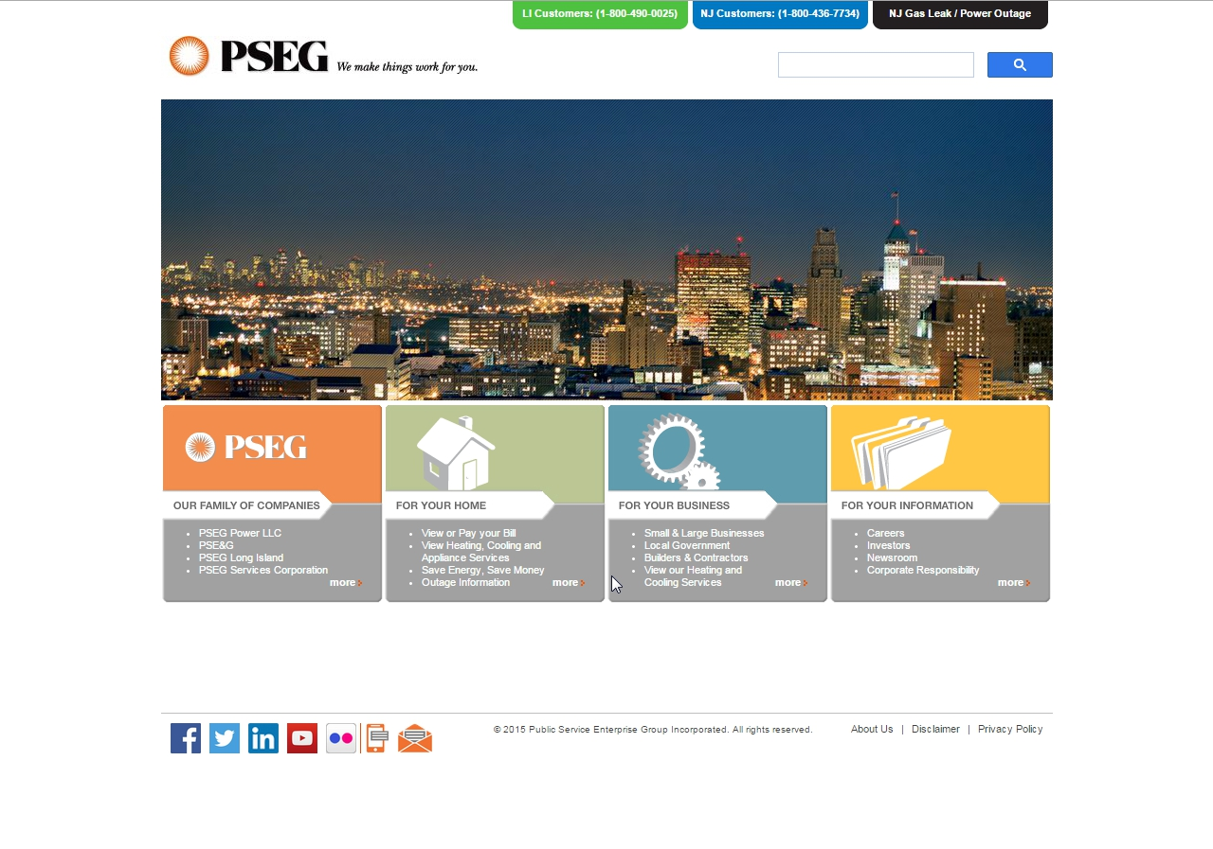

Clearviewenergy.com

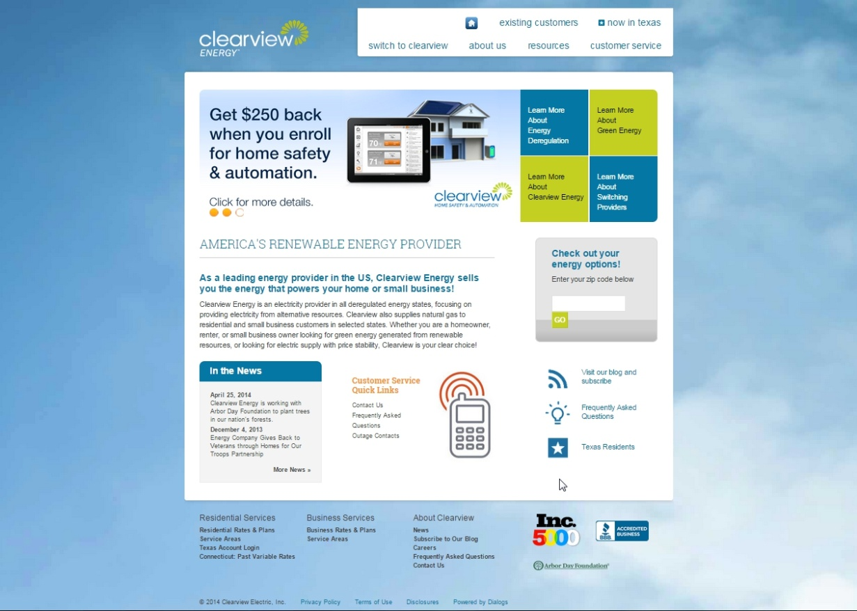

Nrel.gov

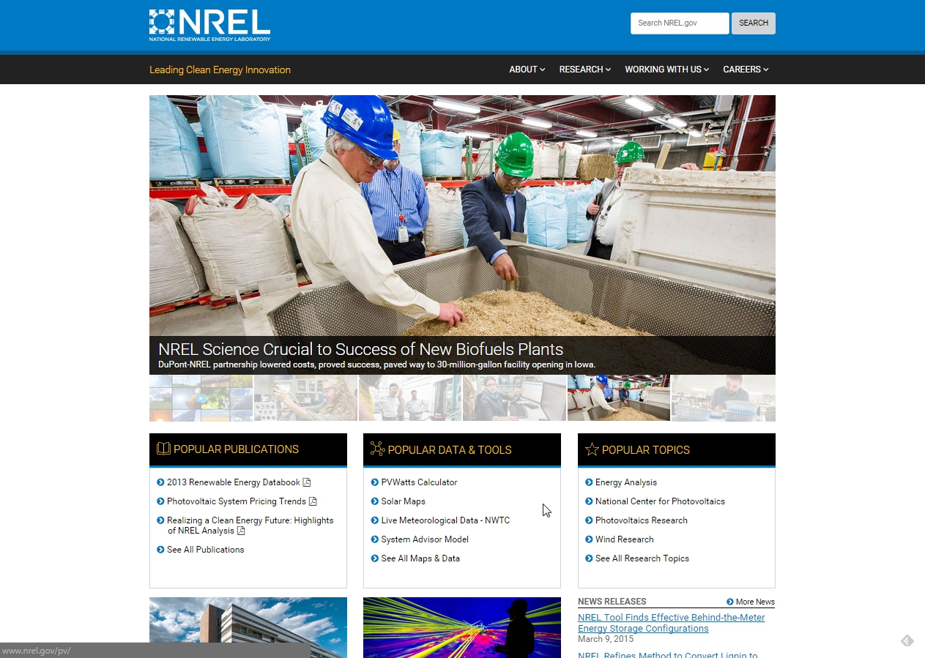

Energypluscompany.com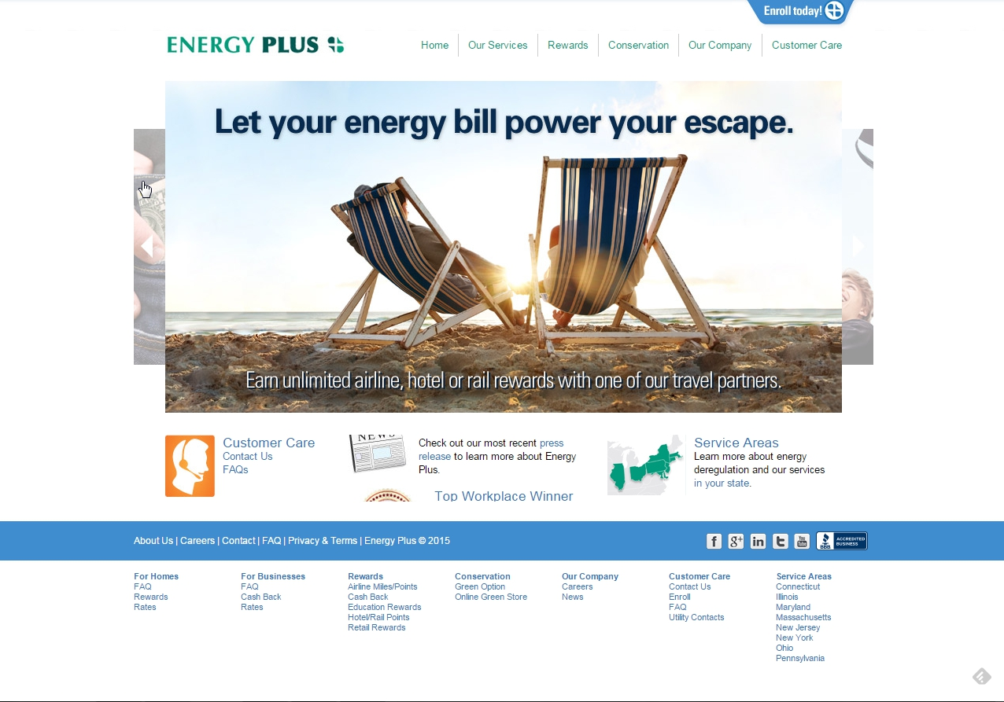

Ambitenergy.com

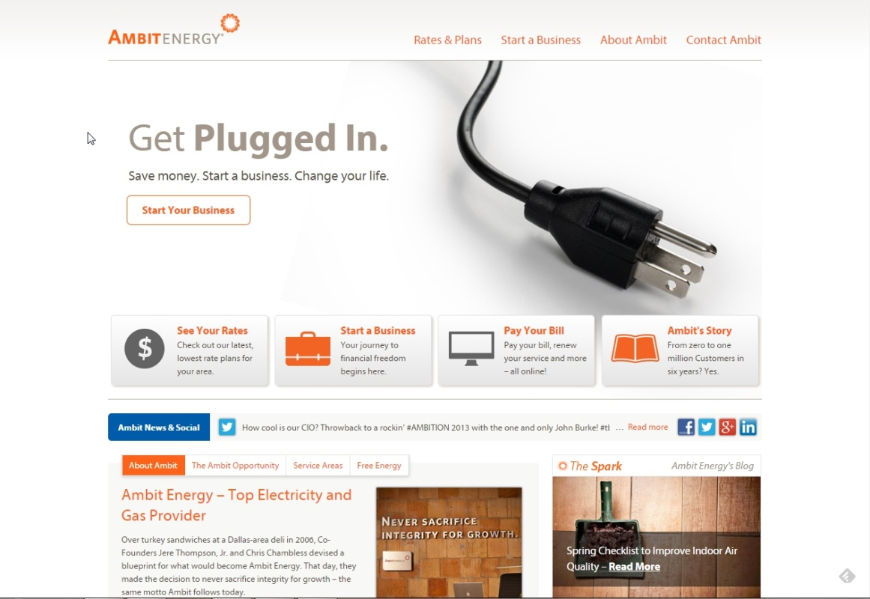

**Proposed Budget :**

**Proposed Schedule :**

**Contact Details :**

Howard Tibbs

Web Developer

609-442-1473

Multitaskic4cs@yahoo.com

**Next Steps :**

I will work on the project proposal upon acceptance of this project brief. If there is no agreement to this project brief, we will discuss any changes, risks, issues, or disagreements. This form is to review the interview and display what information I’ve received. When all terms are met, we will proceed with the project proposal.

# Author’s Signature ______________________________________________________

**Client’s Signature** ____________________________________________________